ITA0305- Mobile Computing
LAB EXPERIMENT
Name: G.Ganesh
Reg NO:192373008

12. Use Figma to create an interactive diagram illustrating the evolution from 1G to 5G

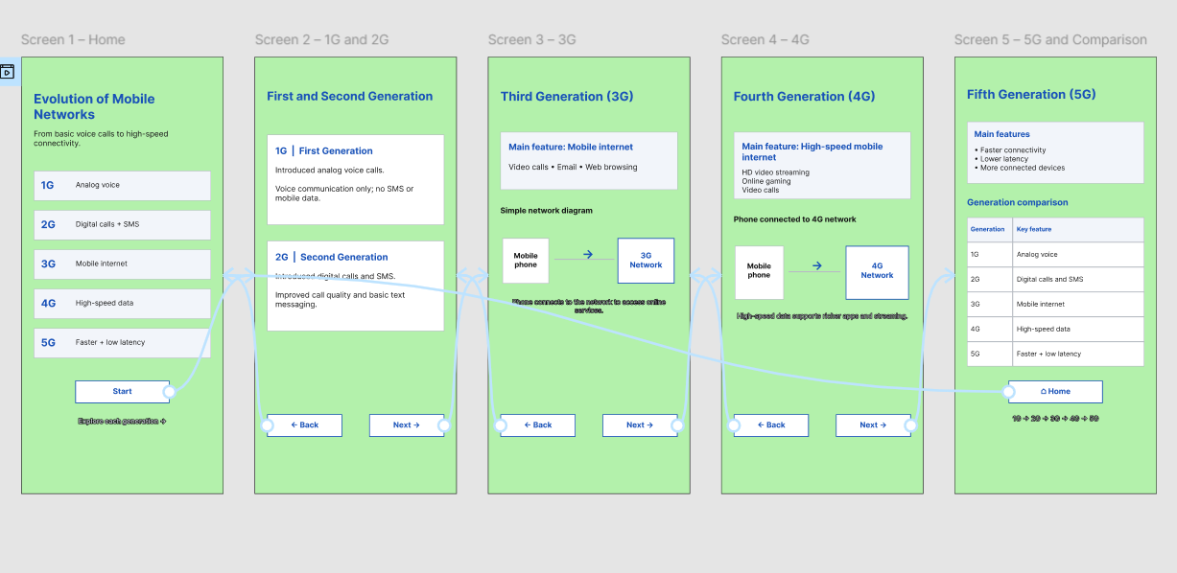
https://www.figma.com/design/oZsz8stnwf3QTkjt5UFYtK/program12?node-id=0-1&p=f&t=xvSIYkE2smtsJEUJ-0

